NM PROJECT REPORT
AI POWERED
LEGAL DOCUMENT
GENERATOR
Automating the drafting of legal documents using Artificial Intelligence
Student Name
Register Number
Department / Course
College / Institution
Project Guide
Academic Year
Submitted as part of the NM Project

Acknowledgement & Declaration

Acknowledgement
I sincerely thank everyone who supported me in completing this project on the AI Powered Legal Document Generator.
I am grateful to my project guide and faculty members for their guidance and encouragement, to my institution for providing the resources and environment to learn, and to the NM programme trainers for the industry-focused skills that made this work possible.
I also thank my family and friends for their constant support and motivation throughout the project.

Declaration
I hereby declare that this project report is the result of my own work. It has not been submitted to any other institution or programme for any other purpose. All sources of information used in this report have been acknowledged.

Signature: ____________________
Date: ____________________

Abstract
Preparing legal documents such as rental agreements, affidavits and non-disclosure agreements is slow, costly and confusing for most people. Small businesses, students and first-time users often depend on outdated templates or expensive professional help.
This project presents an AI Powered Legal Document Generator, a web application that asks users simple questions and automatically drafts a complete, well-structured legal document. It combines a Large Language Model (LLM) with a verified clause library and a validation step, so the output is accurate, consistent and easy to understand.
The system reduces drafting time from hours to minutes, lowers cost, and makes basic legal documentation accessible to everyone. It is a drafting aid; final review by a qualified lawyer is recommended.

Keywords: Artificial Intelligence, Large Language Model, Legal Technology, Document Automation, Natural Language Processing

Project at a Glance
Item | Details
Domain | Legal Technology (LegalTech) and Artificial Intelligence
Approach | LLM drafting with clause retrieval (RAG) and rule-based validation
Input | Simple form answers given by the user
Output | Ready-to-review legal document in DOCX and PDF
Target Users | Individuals, students, startups, small businesses

Table of Contents

Acknowledgement & Declaration 2
Abstract 3
1. Introduction 5
2. Problem Statement 6
3. Objectives and Scope 7
4. Existing Systems and Gap Analysis 8
5. Proposed System 9
6. System Architecture 10
7. Technology Stack 11
8. Key Modules 12
9. Workflow 13
10. Supported Legal Documents 14
11. Implementation Approach 15
12. Security, Privacy and Ethics 16
13. Testing and Evaluation 17
14. Benefits and Limitations 18
15. Future Enhancements 19
16. Conclusion 20
References 21

1. Introduction
Legal documents are part of everyday life: renting a house, hiring an employee, starting a business or signing an agreement. Yet drafting them requires legal knowledge, time and money that many people do not have.
Recent progress in Artificial Intelligence, especially Large Language Models (LLMs), allows computers to understand instructions and produce well-structured text. This project applies that capability to legal drafting: the user answers a few questions and the system generates a complete document in minutes.

Background
- Legal drafting is repetitive: most agreements follow standard structures.
- Errors or missing clauses can cause disputes and financial loss.
- Digital India initiatives are increasing demand for online legal services.

Why AI for Legal Documents?
Benefit | Explanation
Speed | Draft ready in minutes instead of hours or days
Cost | Reduces dependence on paid drafting for routine documents
Consistency | Same quality and structure every time
Accessibility | Simple language, available 24/7 to anyone online

Important Note
This system assists with drafting. It does not replace a licensed lawyer, and generated documents should be reviewed before use.

2. Problem Statement
Ordinary users face many obstacles when they need a legal document. Professional drafting is expensive, online templates are generic, and legal language is hard to understand. As a result, people either skip proper documentation or sign documents they do not fully understand.

Key Problems
Problem | Impact on the User
High lawyer fees | Routine documents become unaffordable for individuals and startups
Time-consuming process | Days of waiting for a simple agreement
Complex legal language | Users sign terms they do not understand
Human error | Missing clauses, wrong names or dates, weak protection
Inconsistent formats | Different structure and quality across documents
Limited local access | Legal help is scarce in small towns and regional-language users

Problem in One Line
There is no simple, affordable and reliable way for common users to generate accurate legal documents quickly.

3. Objectives and Scope

Objectives
- Build a web application that generates legal documents from simple user inputs.
- Use AI to draft clear, correct and well-structured clauses.
- Validate every draft against a checklist of mandatory clauses.
- Reduce drafting time and cost for routine legal documents.
- Export the final document in editable (DOCX) and print-ready (PDF) formats.

Scope of the Project
In Scope | Out of Scope
Common documents: rental agreement, NDA, affidavit, offer letter | Court filings and litigation strategy
Guided question form and AI drafting | Providing binding legal advice
Clause validation and plain-language summary | Complex, high-value corporate contracts
DOCX and PDF export | Physical stamping and registration
English language (Tamil and Hindi planned later) | Representation before authorities

Target Users
Individuals, tenants and landlords, students, freelancers, startups and small businesses.

4. Existing Systems and Gap Analysis
Before designing the system, current ways of creating legal documents were compared.
Approach | Strengths | Limitations
Lawyer drafting | Accurate, personalised | Costly and slow
Static template websites | Cheap, quick | Rigid, generic, no customisation
General AI chatbots | Flexible, fast | May invent clauses, no validation
Proposed system | Fast, guided, validated, customisable | Needs human review for complex cases

Gap Identified
- Templates lack flexibility; chatbots lack reliability.
- Few tools combine AI drafting with a verified clause library.
- Most tools offer no automatic check for missing or risky clauses.
- Very few options support regional legal context and local languages.

Our Approach
Combine the flexibility of AI with the reliability of verified templates and automatic validation.

5. Proposed System
The proposed AI Powered Legal Document Generator is a web platform in which the user selects a document type, answers guided questions, and receives a complete draft. The AI engine writes the clauses, a validation module checks them, and the user can review, edit and download the final document.

Key Features
- Guided questionnaire: simple questions instead of legal jargon.
- AI drafting: clear clauses generated from user inputs.
- Clause library: verified standard clauses reduce errors.
- Validation: automatic check for missing or conflicting terms.
- Plain-language summary: explains the document in simple words.
- Export: download as DOCX or PDF.

Who Uses the System
User | How They Use It
General user | Generates documents such as rental agreements and affidavits
Small business | Creates NDAs, offer letters and service agreements
Legal reviewer | Reviews, edits and approves drafts
Administrator | Manages templates, clause library and users

6. System Architecture
The system follows a layered architecture. Each layer has a single responsibility, which keeps the system easy to maintain and extend.
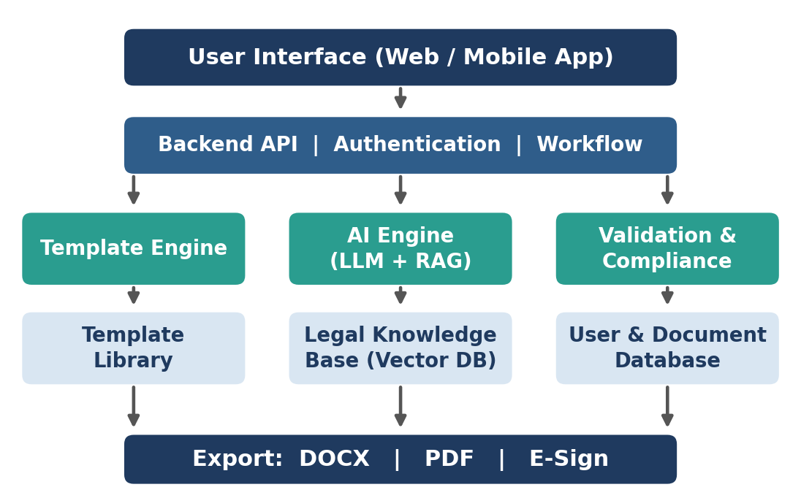
- Presentation layer: web interface for forms, preview and download.
- Application layer: backend API for authentication and workflow control.
- AI layer: template engine, LLM with retrieval, and validation.
- Data layer: template library, legal knowledge base and user records.

7. Technology Stack
The technologies below are chosen for reliability, community support and ease of development.
Layer | Technology | Purpose
Frontend | React.js, Tailwind CSS | Responsive user interface
Backend | Python, FastAPI | REST APIs and business logic
AI Model | LLM API (e.g., Claude) | Clause and document generation
Retrieval | Vector database (FAISS / ChromaDB) | Find relevant clauses and legal context
Templates | Jinja2, python-docx | Fill and format documents
Database | PostgreSQL | Users, documents, audit logs
Export | python-docx, ReportLab | Create DOCX and PDF files
Security | JWT, HTTPS/TLS | Login protection and secure transfer
Deployment | Docker, cloud hosting | Portable, scalable deployment

Flexibility
Any modern LLM can be used. The architecture keeps the AI model replaceable without changing the rest of the system.

8. Key Modules
The system is divided into six modules. Each performs one clear task.
Module | Description | Output
1. User Input | Collects details through a guided form with validation | Structured data
2. Template Selection | Chooses document type and jurisdiction rules | Base template
3. AI Drafting Engine | Writes clauses from inputs using the LLM | Draft document
4. Clause Retrieval (RAG) | Fetches verified clauses and legal context to guide the AI | Reliable clauses
5. Validation & Review | Checks mandatory clauses, names, dates and conflicts | Issue report
6. Export & Storage | Creates DOCX/PDF and saves history securely | Final file

Design Principle
Separate modules make the system easy to test, upgrade and maintain.

9. Workflow
The user moves through six simple steps, from selecting a document to downloading the final file.
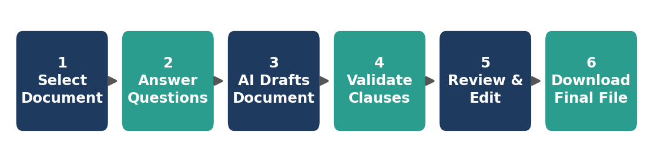
Step | Action | Result
1 | User selects the document type | Correct template loaded
2 | User answers guided questions | Inputs collected
3 | AI drafts clauses using inputs and retrieved clauses | First draft
4 | Validation module checks the draft | Issues flagged
5 | User reviews and edits the draft | Approved version
6 | System exports DOCX or PDF | Final document

10. Supported Legal Documents
The first version supports common, high-demand documents with well-defined structures.
Document | Purpose | Key Inputs
Rental / Lease Agreement | Property rent between landlord and tenant | Parties, rent, deposit, duration
Non-Disclosure Agreement | Protect confidential information | Parties, scope, term
Employment Offer Letter | Terms of a job offer | Role, salary, joining date
Affidavit | Sworn statement of facts | Name, address, statement
Power of Attorney | Authorise someone to act for you | Principal, agent, powers
Sale Agreement | Sale of goods or property | Seller, buyer, price, terms
Legal Notice | Formal notice for a dispute | Sender, receiver, issue
Service Agreement | Freelance or business services | Scope, fees, timeline

11. Implementation Approach

Prompt Design
A structured prompt controls the AI. It states the document type, jurisdiction, user inputs and strict rules, so the output stays accurate and relevant.
You are a legal drafting assistant.
Document : Rental Agreement
Region : Tamil Nadu, India
Inputs : landlord, tenant, rent, deposit, duration
Rules : Use plain English and numbered clauses.
Include mandatory clauses from the library.
Do not invent facts. Mark missing data as [TBD].
Output : Structured clauses (JSON)

Core Logic
inputs = collect_user_inputs(doc_type)
clauses = retrieve_clauses(doc_type, region)
draft = llm.generate(build_prompt(inputs, clauses))
issues = validate(draft, mandatory_checklist)
if issues: draft = llm.revise(draft, issues)
file = render_template(draft, format='DOCX')

Reliability
Retrieval-Augmented Generation (RAG) grounds the AI in verified clauses, which reduces made-up content.

12. Security, Privacy and Ethics
Legal documents contain personal and sensitive data, so protection is built into the design.
Area | Measure Taken
Data in transit | All traffic secured with HTTPS / TLS
Data at rest | Encrypted storage for documents and user data
Access control | Login with JWT tokens and role-based permissions
Privacy compliance | Consent, minimal data collection and deletion on request, following the principles of India's Digital Personal Data Protection Act, 2023
AI reliability | Clause retrieval, validation checks and human review to limit incorrect output
Transparency | Clear disclaimer that the tool is not a substitute for legal advice
Audit | Activity logs to trace document creation and changes

Ethical Use
The system supports users but does not give legal advice. Users are always shown a disclaimer and encouraged to consult a lawyer for important matters.

13. Testing and Evaluation
The system is tested at functional, quality and usability levels.

Sample Test Cases
Test Case | Input | Expected Result
Valid rental inputs | All fields filled correctly | Complete agreement generated
Missing field | Rent amount left blank | Form asks user to complete the field
Mandatory clause check | Draft without termination clause | Validation flags the missing clause
Export | Approved draft | Correct DOCX and PDF downloaded
Unauthorised access | Open another user's document | Access denied

Evaluation Metrics
Metric | How It Is Measured | Target
Clause completeness | Mandatory clauses present in the draft | 90% or more
Generation time | Time from submit to draft | Under 30 seconds
Readability | Feedback from test users | Clear to non-lawyers
User satisfaction | Short survey after use | Positive rating

14. Benefits and Limitations
Benefits | Limitations
Saves time: drafts in minutes | Cannot replace a qualified lawyer
Reduces cost for routine documents | AI output may need correction
Simple language and guided process | Limited to supported document types
Consistent and validated structure | Laws change, so templates need regular updates
Available anytime, from anywhere | Requires internet access
Easy to extend with new templates | Regional language support still in progress

Balanced View
The tool is best for routine, standard documents. Complex or high-value matters should always be reviewed by a professional.

15. Future Enhancements
The project can grow into a complete legal assistant platform.
Enhancement | Description
Multilingual support | Generate and explain documents in Tamil, Hindi and other languages
Voice input | Let users speak their details instead of typing
E-signature and e-stamping | Sign and stamp documents digitally
Contract risk analysis | Upload an existing contract and highlight risky clauses
Lawyer review marketplace | Connect users to verified lawyers for a quick review
Mobile app | Android and iOS apps for easier access
Smart clause suggestions | Recommend extra clauses based on the user's situation

16. Conclusion
The AI Powered Legal Document Generator shows how Artificial Intelligence can make legal documentation faster, cheaper and easier to understand. By combining an LLM with verified clauses and automatic validation, the system produces reliable drafts while keeping the user in control.
The project achieves its main goal: helping common users create routine legal documents without deep legal knowledge. With continued improvement in language support, validation and integrations, it can become a practical tool for individuals and small businesses.

Key Takeaway
AI does not replace legal expertise. It removes repetitive drafting work so that people can get accurate, understandable documents quickly.

References

- The Indian Contract Act, 1872. Government of India.
- The Information Technology Act, 2000. Government of India.
- The Digital Personal Data Protection Act, 2023. Government of India.
- Vaswani, A. et al. (2017). Attention Is All You Need. Advances in Neural Information Processing Systems.
- Brown, T. et al. (2020). Language Models are Few-Shot Learners. NeurIPS.
- Lewis, P. et al. (2020). Retrieval-Augmented Generation for Knowledge-Intensive NLP Tasks. NeurIPS.
- Chalkidis, I. et al. (2020). LEGAL-BERT: The Muppets Straight Out of Law School. Findings of EMNLP.
- FastAPI Documentation. https://fastapi.tiangolo.com
- Anthropic API Documentation. https://docs.claude.com

